- GO TO PEACOCK.MILAULAS (https://peacock.milaulas.com )
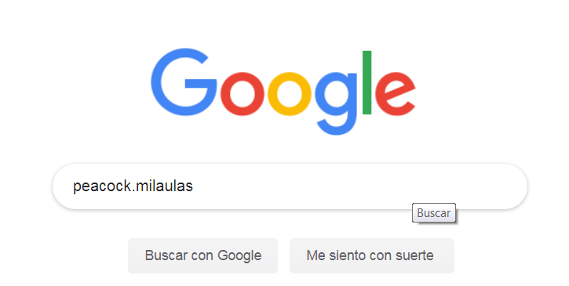
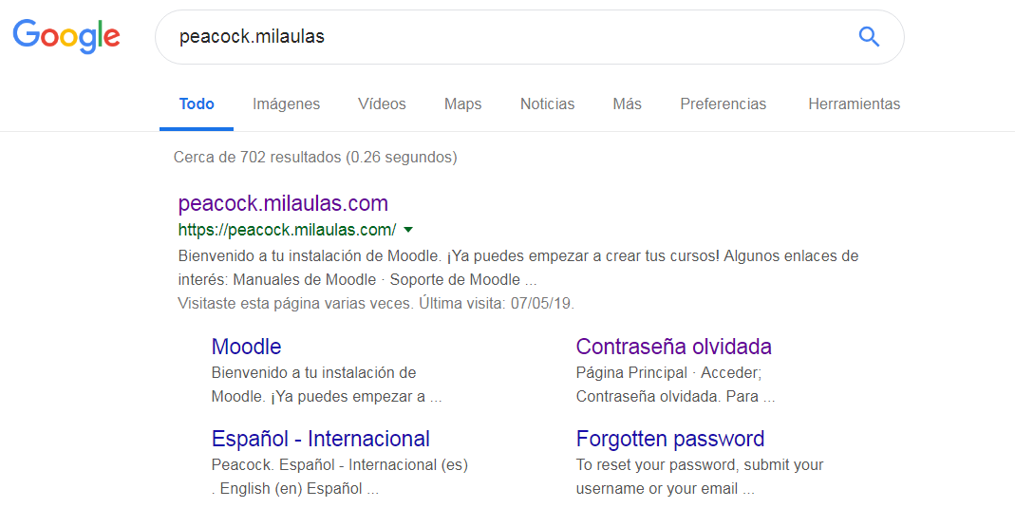

- CLICK ISA ENGLISH 3
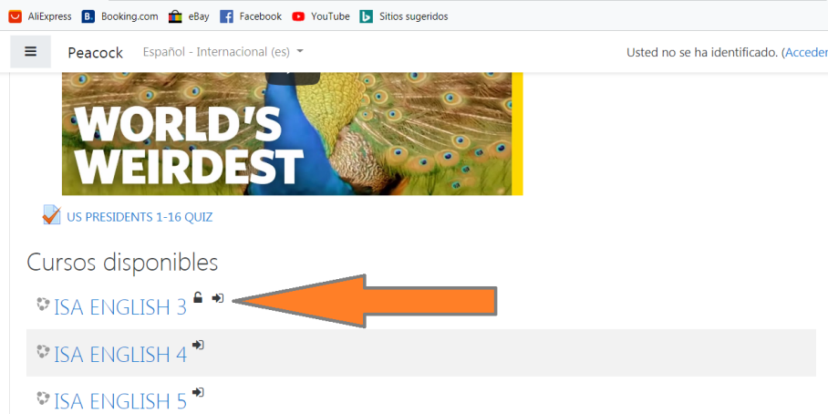

- SCROLL DOWN TO THE BOTTOM
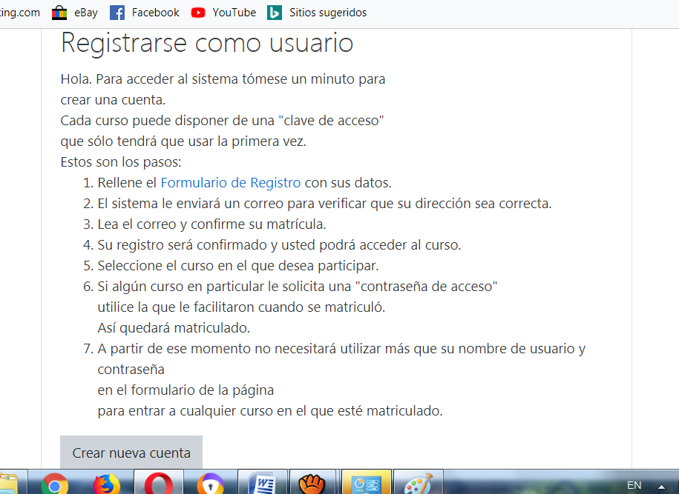
- CREATE A NEW ACCOUNT
