Space to upload the Final Production

Topics of the final production
FINAL PROJECT.
1. Talk about the things you want to do in your life within the next 5 years.
2. Write a composition about the things we can do in order to have a healthier life. You may include a list of actions and habits that help to have a healthier life: express what he/she should and shouldn’t eat and drink. Healthy actions that can be done at home or away from home. Also include other habits you could suggest for a healthier life.
3. Write a composition describing your community. Include the following:
Name of the community, its location, places that it has, express the good and bad things that are in your community. Talk about its people. You may include any other information of interest that you consider relevant. Make sure to put all this information in a word file using images according to what you suggest.
Then you must record a 2 or 3 minutes video where you'll have to read the development of your final production. Upload it on www.youtube.com, send the link or just send the video to the platform in any format.
Finally: you have to send the word file containing your project to the space of final productions in the platform. If needed remember to copy the link of the video.
*Presentation sheet
*Development (arial letter # 12)
*List of new words or phrases that you learned in the project.
Use different sources of information such as your textbook and the web.
Temas de la producción final
Proyecto final.
1. Hablar acerca de las cosas que desea realizar en los próximos 5 años.
2. Escribir una composición sobre las cosas que podemos hacer para tener una vida más saludable. Usted puede incluir una lista de acciones y hábitos que ayudan a tener una vida más saludable: exprese lo que debe y no debe comer y beber. Acciones saludables que se pueden hacer en casa o fuera de casa. También incluya otros hábitos que usted podría sugerir para una vida más sana.
3. Escribe una composición donde describirás tú comunidad. Incluya lo siguiente: nombre de la comunidad, su ubicación, lugares que tiene, exprese las cosas buenas y malas que hay en su comunidad. Hablar de su gente. Usted puede incluir cualquier otra información de interés que considere pertinente.
Asegúrate de poner toda esta información en un archivo de Word usando imágenes de acuerdo a lo que sugieras.
A continuación, debe grabar un vídeo de 2 o 3 minutos en el que tendrá que leer el desarrollo de su producción final. Cárguelo en www.youtube.com, envíe el enlace o simplemente envíe el vídeo a la plataforma en cualquier formato.
Finalmente: tienes que enviar el archivo de Word que contiene tu proyecto al espacio de las producciones finales en la plataforma. Si es necesario recuerda copiar el link del video.
Favor ver que el link de YouTube no esté en modo privado pues de esta manera no se puede ver y no se podrá calificar su trabajo.
* Hoja de presentación
* Desarrollo (letra Arial # 12)
* Lista de nuevas palabras o frases que hayas aprendido en el proyecto.
Utilice diferentes fuentes de información como su libro de texto y la web.

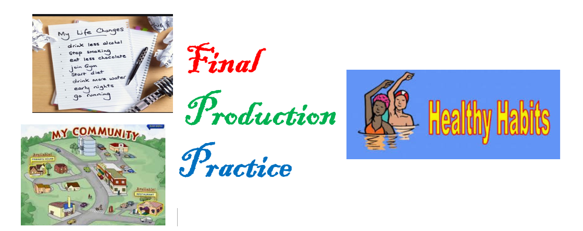
Hello everybody. My name is Amy. I am a student in UAPA university. I’m going to talk about the things I want to do in my life in the future. Well, I want to graduate from the university. Then I want to get a job as an accountant in a big company. I want to get married and have 2 children. I want to travel to Boston. I want to buy a big house and a nice car.
Now let me tell you about the things that you can do in order to have a healthier life.
- you should eat more fruit and vegetables.
- you should drink 8 to 10 glasses of water every day.
- you should go to the gym and do exercise.
- you shouldn’t smoke cigarettes.
- you shouldn’t drink alcohol and soda.
- you shouldn’t eat junk food like hot dogs, pizza and candies.
Now I’m going to describe my community.
I live in los Corralitos in the city of Jarabacoa. In my neighborhood there is a pharmacy, a school, a clinic, a grocery store, a beauty salon and a clothing store. The people of my community are friendly and helpful. The river Yaque del Norte is near my house. Here there is a beautiful view of the mountain and the trees. You can have a picnic or relax with your family. The good thing about living here in my community is that it is very relaxing and quiet. The bad thing is that sometimes we have problem with the electricity and the internet.
Here are some pictures of my community.
https://www.youtube.com/watch?v=WspqMRd1OqA
