ENGLISH 4 EXPOSITIONS
GROUP 1 PLACES IN MY COMMUNITY

EXAMPLES
- I NEED TO GO TO THE POST OFFICE TO SEND A LETTER.

- SHE NEEDS TO CALL THE DOCTOR AT THE HOSPITAL

- WE WANT TO TAKE THE CHILDREN TO THE PLAYGROUND

- HE HAS A TOOTHACHE. HE NEEDS TO GO TO THE DENTIST

- THEY WANT TO MAKE A RESERVATION IN THAT HOTEL

- WHAT DO YOU WANT TO RENT: A HOUSE OR AN APARTMENT?

- YOU NEED TO MAKE A DEPOSIT TODAY AT THE BANK

- WE CAN WALK IN THE PARK OR PLAY IN THE TENNIS COURT

EXERCISE:
- WHERE CAN YOU GO WHEN YOU ARE SICK?
I CAN GO TO THE ____________________________________

- WHERE CAN YOU SEND A LETTER?
I CAN SEND A LETTER IN THE ___________________________

- WHO CAN YOU CALL WHEN YOU SEE A THIEF?
I CAN CALL THE ______________________________

- WHERE CAN YOU GO WHEN YOU HAVE A TOOTHACHE?
I CAN GO TO THE ____________________________________

- WHERE CAN YOU CALL TO MAKE A RESERVATION?
I CAN CALL TO THE ____________________________________

- WHERE CAN YOU SEE THE CHILDREN PLAYING?
I CAN SEE THEM AT THE ____________________________________

- WHAT DO YOU PREFER TO RENT: A HOUSE OR AN APARTMENT?
I PREFER TO RENT ____________________________________

- WHERE CAN YOU BUY GASOLINE FOR YOUR CAR?
I CAN BUY GASOLINE AT A _________________________

GROUP 2 PREPOSITIONS OF PLACE

EXAMPLES
1. The restaurant is next to the pharmacy.
2. The Church is across from the park.
3. The bank is between the restaurant and the hotel.
4. The playground is in back of the supermarket.
5. The bakery is in front of the hospital.
6. The shopping mall is on the corner of Lincoln and Main Street.
7. The City hall is around the corner.
8. The Clothing store is on the Summer Avenue.

EXERCISE:
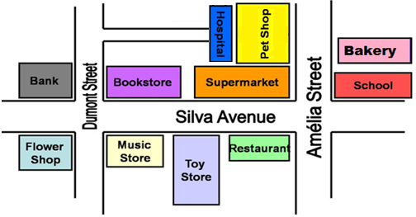

- THE BOOKSTORE IS ___________________ THE SUPERMARKET.

- THE TOY STORE IS ___________________ MUSIC STORE AND THE RESTAURANT
- THE FLOWER SHOP IS ________________ THE MUSIC STORE.

- THE BANK IS ______________ THE CORNER.

- THE PET SHOP IS ______________ THE SUPERMARKET.

- THE IS HOSPITAL IS ______________ THE PET SHOP.
- THE BAKERY IS ________ AMELIA STREET.

- THE SCHOOL IS _________________________ AMELIA STREET AND SILVA AVENUE

GROUP 3 GIVING DIRECTIONS

EXAMPLES
- Where is the post office?
Go straight on Texas street. The post office is next to the church.
- Is there a restaurant near here?
Yes. Turn left on Orange Avenue.
- Can you help me? I'm looking for the Zoo
Turn around on Lion street.
- How can I get to the Police station?
Turn right on Sullivan Street.
- Could you tell me the way to the bank, please?
Of course. Go straight this street and stop on Jefferson Avenue.
- Can you tell me how to get to the cinema, please?
Yes. You have to turn right on Parker Avenue
- What's the best way to go to the church?
You have to go straight and turn left on Bush Street.

EXERCISE

- Where is the Bakery?
______________ on Flower street.

- Is there a hotel near here?
Yes. _____________ on Orange Avenue.

- Can you help me? I'm looking for the School
_____________ on Winter street.

- How can I get to the Police station?
_____________ on Spring Street.

- Could you tell me the way to the Park, please?
Of course. Go straight this street and _______ on Moon Avenue.

- Can you tell me how to get to the Bookstore, please?
Yes. You have to ___________ on Blessing Avenue

GROUP 4 PRESENT CONTINUOUS (PROGRESSIVE)

EXAMPLES
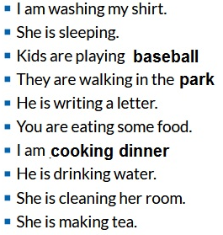

EXERCISE:
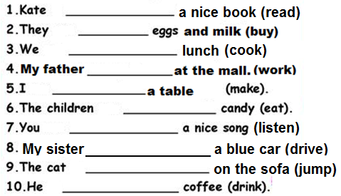

GROUP 5 ADVERBS OF FREQUENCY

EXAMPLES

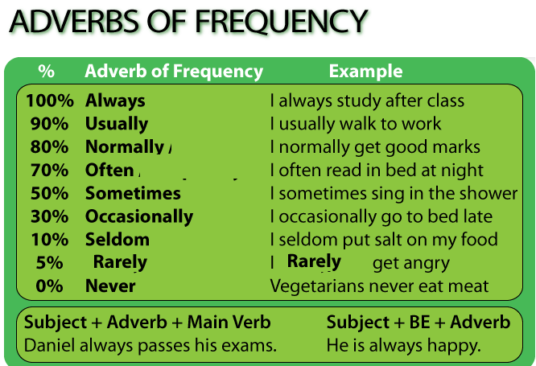

EXERCISE:

- They ________ go to the movies. (70%)
- She ________ listens to pop music. (80%)
- He ________ reads the newspaper. (50%)
- I ________ drink coffee in the morning. (90%)
- You ________ go to the church on Sunday. (100%)
- I ________ go shopping in the afternoon. (10%)
- She ________ helps her daughter with her homework. (30%)
- We ________ watch television in the evening. (70%)
- I ________ smoke. (0%)
- I ________ eat vegetables and fruits. (90%)

GROUP 6 PARTS OF THE BODY

EXAMPLES
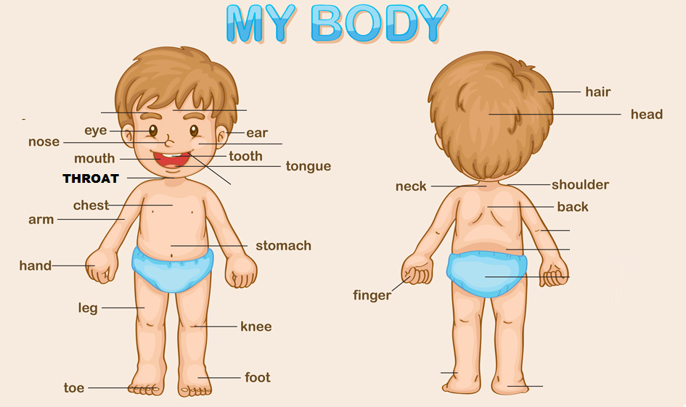

EXERCISE:

- I CAN TALK WITH MY ___________________.

- YOU CAN WRITE WITH YOUR ___________________ .

- MY BOTHER CAN LISTEN WITH HIS ___________________ .

- SHE CAN SEE WITH HER ___________________ .

- WE CAN EAT WITH OUR ___________________ .

- THEY CAN SMELL WITH THEIR ___________________ .

- THE CAT CAN BITE WITH ITS ___________________ .

- ROBERT CAN POINT WITH HIS ___________________ .

- MY SON CAN KICK WITH HIS ___________________ .

- WE CAN HUG WITH OUR ___________________ .

GROUP 7 ILLNESSES AND HEALTH PROBLEMS

EXAMPLES

- WHAT´S THE MATTER? – I HAVE A COUGH
- I FEEL VERY SICK TODAY. I HAVE A THE FLU
- MY WIFE IS SICK. SHE HAS AN EARACHE
- THE BABY IS VERY HOT. HE HAS A FEVER
- I NEED TO TAKE ASPIRIN. I HAVE A HEADACHE
- YOU CAN´T SPEAK. YOU HAVE A SORE THROAT
- I NEED TO GO TO THE DENTIST. I HAVE A TOOTHACHE
- HE NEEDS TO GO TO THE DOCTOR. HE HAS A STOMACHACHE
- OUCH!!! THIS BACKACHE IS KILLING ME.

EXERCISE: CHECK THE MIMIC AND COMPLETE THE SENTENCES

- She has a very bad ___________________
- We have a horrible ______________________
- I have a terrible ___________________________
- She has an awful ___________________________
- Lucy has a very bad ___________________
- You have a bad ______________________
- They have a terrible ___________________________
- The cat has an awful ___________________________
- My husband has an awful ___________________________

GROUP 8 SHOULD or SHOULDN’T

EXAMPLES

- She has the flu. She should stay at home.
- He has a backache. He shouldn’t carry that heavy box
- She has a headache. She should take aspirin.
- He has a stomachache. He should take antacid.
- You have a runny nose. You shouldn’t wear perfume.
- Daisy has dirty hands. She should wash her hands.
- My brother has toothache. He shouldn’t eat candies.
- Jennifer has a broken arm. She shouldn’t play volleyball.

EXERCISE: COMPLETE WITH SHOULD or SHOULDN’T

- He feels tired. He ………….. stop working for today.
- Caroline has a sore throat. She ……….. go to a doctor.
- She drank whisky. She ………….. drive home.
- He has a cough. He …………….. smoke cigarette.
- She has a toothache. She ………… go to a dentist.
- Matt is fat. He …………. eat hot dogs and hamburgers
- Alice isn’t fit. She …………. go to the gym and exercise.
- She has headache. She ……………….. take aspirin.

GROUP 9 JOBS and WORKPLACES

EXAMPLES

- My uncle is a chef. He works in a big hotel.
- Susan is a custodian. She cleans the bathrooms in a bank.
- My sister is a cashier. She works with money in a supermarket.
- Her wife is a secretary. She works in an office.
- Peter is a good teacher. He works in a school.
- My father is a mechanic. He can fix the vehicles in a garage.
- Stacy is a nurse. Her husband is a doctor. They work in a hospital.
- My friend Louis is a server. He serves food in a restaurant.
EXERCISE: CIRCLE THE CORRECT OCCUPATION

1) This person teaches students in a high school.
A. student B. dentist C. teacher D. bus driver

2) This person cooks food in a restaurant.
A. chef B. Police officer C. waiter D. teacher

3) This person works in a hospital or clinic
A. Mail carrier B. Nurse C. singer D. Policeman

4) This person repairs cars or motorcycles.
A. waiter B. mechanic C. singer D. chef

5) This person takes care of teeth.
A. Receptionist B. Chef C. dentist D. fire fighter

6) This person works with money in a supermarket.
A. doctor B. teacher C. server D. cashier

7) This person cleans in a company or school.
A. teacher B. cook C. custodian D. waiter

8) This person can fly a plane.
A. Policeman B. chef C. pilot D. nurse

9) This person answers the phone in a company.
A. teacher B. Receptionist C. truck driver D. waiter

GROUP 10 DON’T or DOESN’T

EXAMPLES

- I don’t have a headache.
- He doesn’t take antacid for a stomachache
- She doesn’t drink coffee in the morning
- We don’t buy medicine for the backache
- You don’t eat garlic for the earache
- They don’t go to the dentist for that toothache
- My father doesn’t drive an ambulance at the hospital
- The dog doesn’t sleep in my bed

EXERCISE: COMPLETE WITH DON’T or DOESN’T

- Michael is a custodian. He ________ work with computers.
- My sister is very lazy. She _______ like to work.
- I´m a secretary. I _______ take care of sick people.
- They are mechanics. They _______ fix cars in a garage.
- Lisa is a nurse. She _______ clean the bathrooms.
- Mr. Brown is a teacher. He _______ cook in a restaurant.
- The cat has a fever. It _______ have a sore throat.
- We want to buy cough syrup, but we ______ have money.

GROUP 11 SIMPLE PAST

EXAMPLES

- I was a server. I cleaned the table.
- He worked in a restaurant. He cooked dinner.
- She worked in the post office. She delivered packages.
- We were cashiers. We counted the money.
- You were a manager. You helped other workers.
- Richard was a mechanic. He fixed vehicles in a garage.
- My wife was a salesperson. He talked to customers.
- Sammy was a teacher. He prepared English lessons.

EXERCISE: COMPLETE WITH THE SIMPLE PAST

- Peter was a custodian. He ________ the classrooms. (clean)
- My sister ____ a secretary. She ______ letters in a computer. (type)
- I ____ a nurse. I _______ the doctor with the patients. (help)
- They ____ mechanics. They _______ cars and motorcycles. (fix)
- My mother _____ a teacher. She _______ in a school. (work)
- Liz ____ a cashier. She _______ money in a supermarket. (count)
- Tom _____ riding a scooter. He _______ food (deliver).
- I ____ a student. I often ______my homework on time. (finish)

ENGLISH 4 EXPOSITIONS
GROUP 1 PLACES IN MY COMMUNITY

EXAMPLES
- I NEED TO GO TO THE POST OFFICE TO SEND A LETTER.

- SHE NEEDS TO CALL THE DOCTOR AT THE HOSPITAL

- WE WANT TO TAKE THE CHILDREN TO THE PLAYGROUND

- HE HAS A TOOTHACHE. HE NEEDS TO GO TO THE DENTIST

- THEY WANT TO MAKE A RESERVATION IN THAT HOTEL

- WHAT DO YOU WANT TO RENT: A HOUSE OR AN APARTMENT?

- YOU NEED TO MAKE A DEPOSIT TODAY AT THE BANK

- WE CAN WALK IN THE PARK OR PLAY IN THE TENNIS COURT

EXERCISE:
- WHERE CAN YOU GO WHEN YOU ARE SICK?
I CAN GO TO THE ____________________________________

- WHERE CAN YOU SEND A LETTER?
I CAN SEND A LETTER IN THE ___________________________

- WHO CAN YOU CALL WHEN YOU SEE A THIEF?
I CAN CALL THE ______________________________

- WHERE CAN YOU GO WHEN YOU HAVE A TOOTHACHE?
I CAN GO TO THE ____________________________________

- WHERE CAN YOU CALL TO MAKE A RESERVATION?
I CAN CALL TO THE ____________________________________

- WHERE CAN YOU SEE THE CHILDREN PLAYING?
I CAN SEE THEM AT THE ____________________________________

- WHAT DO YOU PREFER TO RENT: A HOUSE OR AN APARTMENT?
I PREFER TO RENT ____________________________________

- WHERE CAN YOU BUY GASOLINE FOR YOUR CAR?
I CAN BUY GASOLINE AT A _________________________

GROUP 2 PREPOSITIONS OF PLACE

EXAMPLES
1. The restaurant is next to the pharmacy.
2. The Church is across from the park.
3. The bank is between the restaurant and the hotel.
4. The playground is in back of the supermarket.
5. The bakery is in front of the hospital.
6. The shopping mall is on the corner of Lincoln and Main Street.
7. The City hall is around the corner.
8. The Clothing store is on the Summer Avenue.

EXERCISE:

- THE BOOKSTORE IS ___________________ THE SUPERMARKET.

- THE TOY STORE IS ___________________ MUSIC STORE AND THE RESTAURANT
- THE FLOWER SHOP IS ________________ THE MUSIC STORE.

- THE BANK IS ______________ THE CORNER.

- THE PET SHOP IS ______________ THE SUPERMARKET.

- THE IS HOSPITAL IS ______________ THE PET SHOP.
- THE BAKERY IS ________ AMELIA STREET.

- THE SCHOOL IS _________________________ AMELIA STREET AND SILVA AVENUE

GROUP 3 GIVING DIRECTIONS

EXAMPLES
- Where is the post office?
Go straight on Texas street. The post office is next to the church.
- Is there a restaurant near here?
Yes. Turn left on Orange Avenue.
- Can you help me? I'm looking for the Zoo
Turn around on Lion street.
- How can I get to the Police station?
Turn right on Sullivan Street.
- Could you tell me the way to the bank, please?
Of course. Go straight this street and stop on Jefferson Avenue.
- Can you tell me how to get to the cinema, please?
Yes. You have to turn right on Parker Avenue
- What's the best way to go to the church?
You have to go straight and turn left on Bush Street.

EXERCISE

- Where is the Bakery?
______________ on Flower street.

- Is there a hotel near here?
Yes. _____________ on Orange Avenue.

- Can you help me? I'm looking for the School
_____________ on Winter street.

- How can I get to the Police station?
_____________ on Spring Street.

- Could you tell me the way to the Park, please?
Of course. Go straight this street and _______ on Moon Avenue.

- Can you tell me how to get to the Bookstore, please?
Yes. You have to ___________ on Blessing Avenue

GROUP 4 PRESENT CONTINUOUS (PROGRESSIVE)

EXAMPLES

EXERCISE:
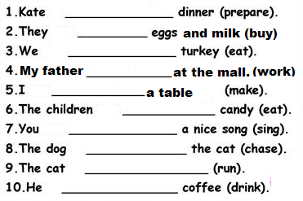

GROUP 5 ADVERBS OF FREQUENCY

EXAMPLES

EXERCISE:

- They ________ go to the movies. (70%)
- She ________ listens to pop music. (80%)
- He ________ reads the newspaper. (50%)
- I ________ drink coffee in the morning. (90%)
- You ________ go to the church on Sunday. (100%)
- I ________ go shopping in the afternoon. (10%)
- She ________ helps her daughter with her homework. (30%)
- We ________ watch television in the evening. (70%)
- I ________ smoke. (0%)
- I ________ eat vegetables and fruits. (90%)

GROUP 6 PARTS OF THE BODY

EXAMPLES

EXERCISE:

- I CAN TALK WITH MY ___________________.

- YOU CAN WRITE WITH YOUR ___________________ .

- MY BOTHER CAN LISTEN WITH HIS ___________________ .

- SHE CAN SEE WITH HER ___________________ .

- WE CAN EAT WITH OUR ___________________ .

- THEY CAN SMELL WITH THEIR ___________________ .

- THE CAT CAN BITE WITH ITS ___________________ .

- ROBERT CAN POINT WITH HIS ___________________ .

- MY SON CAN KICK WITH HIS ___________________ .

- WE CAN HUG WITH OUR ___________________ .

GROUP 7 ILLNESSES AND HEALTH PROBLEMS

EXAMPLES

- WHAT´S THE MATTER? – I HAVE A COUGH
- I FEEL VERY SICK TODAY. I HAVE A THE FLU
- MY WIFE IS SICK. SHE HAS AN EARACHE
- THE BABY IS VERY HOT. HE HAS A FEVER
- I NEED TO TAKE ASPIRIN. I HAVE A HEADACHE
- YOU CAN´T SPEAK. YOU HAVE A SORE THROAT
- I NEED TO GO TO THE DENTIST. I HAVE A TOOTHACHE
- HE NEEDS TO GO TO THE DOCTOR. HE HAS A STOMACHACHE
- OUCH!!! THIS BACKACHE IS KILLING ME.

EXERCISE: CHECK THE MIMIC AND COMPLETE THE SENTENCES

- She has a very bad ___________________
- We have a horrible ______________________
- I have a terrible ___________________________
- She has an awful ___________________________
- Lucy has a very bad ___________________
- You have a bad ______________________
- They have a terrible ___________________________
- The cat has an awful ___________________________
- My husband has an awful ___________________________

GROUP 8 SHOULD or SHOULDN’T

EXAMPLES

- She has the flu. She should stay at home.
- He has a backache. He shouldn’t carry that heavy box
- She has a headache. She should take aspirin.
- He has a stomachache. He should take antacid.
- You have a runny nose. You shouldn’t wear perfume.
- Daisy has dirty hands. She should wash her hands.
- My brother has toothache. He shouldn’t eat candies.
- Jennifer has a broken arm. She shouldn’t play volleyball.

EXERCISE: COMPLETE WITH SHOULD or SHOULDN’T

- He feels tired. He ………….. stop working for today.
- Caroline has a sore throat. She ……….. go to a doctor.
- She drank whisky. She ………….. drive home.
- He has a cough. He …………….. smoke cigarette.
- She has a toothache. She ………… go to a dentist.
- Matt is fat. He …………. eat hot dogs and hamburgers
- Alice isn’t fit. She …………. go to the gym and exercise.
- She has headache. She ……………….. take aspirin.

GROUP 9 JOBS and WORKPLACES

EXAMPLES

- My uncle is a chef. He works in a big hotel.
- Susan is a custodian. She cleans the bathrooms in a bank.
- My sister is a cashier. She works with money in a supermarket.
- Her wife is a secretary. She works in an office.
- Peter is a good teacher. He works in a school.
- My father is a mechanic. He can fix the vehicles in a garage.
- Stacy is a nurse. Her husband is a doctor. They work in a hospital.
- My friend Louis is a server. He serves food in a restaurant.
EXERCISE: CIRCLE THE CORRECT OCCUPATION

1) This person teaches students in a high school.
A. student B. dentist C. teacher D. bus driver

2) This person cooks food in a restaurant.
A. chef B. Police officer C. waiter D. teacher

3) This person works in a hospital or clinic
A. Mail carrier B. Nurse C. singer D. Policeman

4) This person repairs cars or motorcycles.
A. waiter B. mechanic C. singer D. chef

5) This person takes care of teeth.
A. Receptionist B. Chef C. dentist D. fire fighter

6) This person works with money in a supermarket.
A. doctor B. teacher C. server D. cashier

7) This person cleans in a company or school.
A. teacher B. cook C. custodian D. waiter

8) This person can fly a plane.
A. Policeman B. chef C. pilot D. nurse

9) This person answers the phone in a company.
A. teacher B. Receptionist C. truck driver D. waiter

GROUP 10 DON’T or DOESN’T

EXAMPLES

- I don’t have a headache.
- He doesn’t take antacid for a stomachache
- She doesn’t drink coffee in the morning
- We don’t buy medicine for the backache
- You don’t eat garlic for the earache
- They don’t go to the dentist for that toothache
- My father doesn’t drive an ambulance at the hospital
- The dog doesn’t sleep in my bed

EXERCISE: COMPLETE WITH DON’T or DOESN’T

- Michael is a custodian. He ________ work with computers.
- My sister is very lazy. She _______ like to work.
- I´m a secretary. I _______ take care of sick people.
- They are mechanics. They _______ fix cars in a garage.
- Lisa is a nurse. She _______ clean the bathrooms.
- Mr. Brown is a teacher. He _______ cook in a restaurant.
- The cat has a fever. It _______ have a sore throat.
- We want to buy cough syrup, but we ______ have money.

GROUP 11 SIMPLE PAST

EXAMPLES

- I was a server. I cleaned the table.
- He worked in a restaurant. He cooked dinner.
- She worked in the post office. She delivered packages.
- We were cashiers. We counted the money.
- You were a manager. You helped other workers.
- Richard was a mechanic. He fixed vehicles in a garage.
- My wife was a salesperson. He talked to customers.
- Sammy was a teacher. He prepared English lessons.

EXERCISE: COMPLETE WITH THE SIMPLE PAST

- Peter was a custodian. He ________ the classrooms. (clean)
- My sister ____ a secretary. She ______ letters in a computer. (type)
- I ____ a nurse. I _______ the doctor with the patients. (help)
- They ____ mechanics. They _______ cars and motorcycles. (fix)
- My mother _____ a teacher. She _______ in a school. (work)
- Liz ____ a cashier. She _______ money in a supermarket. (count)
- Tom _____ riding a scooter. He _______ food (deliver).
- I ____ a student. I often ______my homework on time. (finish)

